Contents

INTRODUCTION: 2

AIM: 2

THEORY: 2

OBSERVATION TABLE: 6

CALCULATIONS: 10

GRAPHS: 11

ANALYSIS: 13

COMPARISION WITH THEORY: 16

CONCLUSION AND DISSCUSSION: 16

REFRENCE: 18

### INTRODUCTION:

Buckling and bending are fundamental structural behaviors. **Bending** causes gradual deformation under transverse loads, while **buckling** leads to sudden instability in slender structures under compression. Engineers analyze these effects to design safe and efficient structures. *Loading and Buckling of Struts* demonstrates how different struts behave under load, reflecting real-world applications like building supports and structural frameworks.

### AIM:

The aim of this experiment is to verify the simple beam bending equation for a beam on two supports and establish the background for Euler’s formula. It also aims to test struts under different loading conditions, determine their actual stiffness, and calculate the Young’s Modulus of the material. Additionally, the experiment seeks to prove the sinusoidal shape of buckled struts for various end conditions, analyze the relationship between buckling load and end conditions, and demonstrate the principle of effective length in structural stability.

### THEORY:

**Struts**

Struts are structural elements designed to resist compression and support loads in a variety of applications, such as in buildings, frameworks, and machinery. Typically slender and strong, struts can be made from materials like steel, brass, or wood, and come in different shapes and sizes to suit specific structural needs. In experiments, struts are tested for their ability to withstand axial loads, deflection, and buckling, which occur when compressive forces exceed a critical limit. Testing different materials and designs helps determine the optimal strut properties for various engineering applications.

**Beams**

Beams are structural elements designed to support loads across spans, resisting bending, shear, and torsion. Made from materials like steel, concrete, or wood, they come in various shapes, such as rectangular or I-beams. In experiments, beams are tested for bending, deflection, and stress distribution, helping engineers design efficient and safe structures for various applications.

**Difference**

Struts are compression members designed to resist axial loads, often used in support structures, while beams are designed to resist bending under transverse loads. Struts primarily handle compression, whereas beams handle both bending and shear stresses.

**Bending**

Bending is the deformation of a structural element, such as a beam, due to an external load applied perpendicular to its length. It generates internal stresses—tensile on one side and compressive on the other—causing curvature. The bending equation,



relates bending stress to the applied moment, distance from the neutral axis, and moment of inertia. Key factors affecting bending include material stiffness (Young’s modulus), cross-section shape, support conditions, and load distribution.

Beams resist bending based on their **flexural rigidity** (EI), where **E** is Young’s modulus and **I** is the moment of inertia. Beam deflection depends on these properties and is crucial for structural stability. Applications of bending analysis include bridges, buildings, aircraft wings, and mechanical components, ensuring structures can withstand loads with minimal deformation and failure.

**Buckling**

Buckling is a sudden instability that occurs in slender structural elements, like columns or struts, when subjected to compressive forces. Unlike bending, which causes gradual deformation, buckling leads to abrupt lateral deflection once the applied load exceeds a critical limit. Euler’s **critical buckling load** is given by



where **E** is Young’s modulus, **I** is the moment of inertia, and **K** is an end condition factor that influences stability. Different support conditions, material stiffness, cross-section properties, and slenderness ratio affect a strut’s resistance to buckling.

Buckling analysis is essential in designing safe structures, such as buildings, bridges, and aerospace components, where stability under compression is critical. Engineers use concepts like **effective length**, **eccentric loading**, and **lateral-torsional buckling** to optimize structural performance and prevent sudden failures.

**Difference between Bending and Buckling**

Buckling and bending are distinct deformation behaviors in structures. **Buckling** occurs under **axial compression**, leading to sudden lateral deflection when the **critical buckling load** is exceeded. It depends on **slenderness ratio, material stiffness, and end conditions**, with failure caused by instability rather than material yielding. **Bending**, on the other hand, results from **transverse loads**, causing gradual curvature due to **tensile and compressive stresses.**

Buckling is more affected by **end conditions**, common in **columns and struts**, while bending occurs in **beams and cantilevers**. Buckling prevention involves **thicker cross-sections, stiffer materials, or bracing**, while bending resistance improves with **higher moment of inertia or optimized supports**. The key difference is that **buckling is an instability failure under axial load**, whereas **bending is a gradual deformation under transverse load**.

**Modes of Buckling**

Buckling occurs in various modes with distinct wave patterns. **Euler buckling** causes half-wave deflections in slender columns, while **inelastic buckling** results in plastic deformation. **Local buckling** creates ripples in thin-walled sections, **torsional buckling** causes twisting, and **lateral-torsional buckling (LTB)** combines deflection and rotation in beams. **Shell buckling** forms dimples in thin cylinders. Wave patterns depend on boundary conditions, load, and material properties, helping predict failure points and improve stability.

**Effective Length**

The **effective length** in buckling analysis refers to the equivalent length of a column that would buckle similarly to the actual column under the same compressive load, considering its boundary conditions. The **effective length factor (K)**, which depends on the column's end conditions, modifies the actual length to determine the column's stability. For example, a **pinned-pinned column** has K=1.0K = 1.0, a **fixed-free column** has K=2.0K = 2.0, a **fixed-pinned column** has K=0.7K = 0.7, and a **fixed-fixed column** has K=0.5K = 0.5. The effective length factor directly impacts the **critical buckling load**, with shorter effective lengths leading to higher stability. This concept is crucial in structural design, allowing engineers to optimize column configurations for better resistance to buckling.

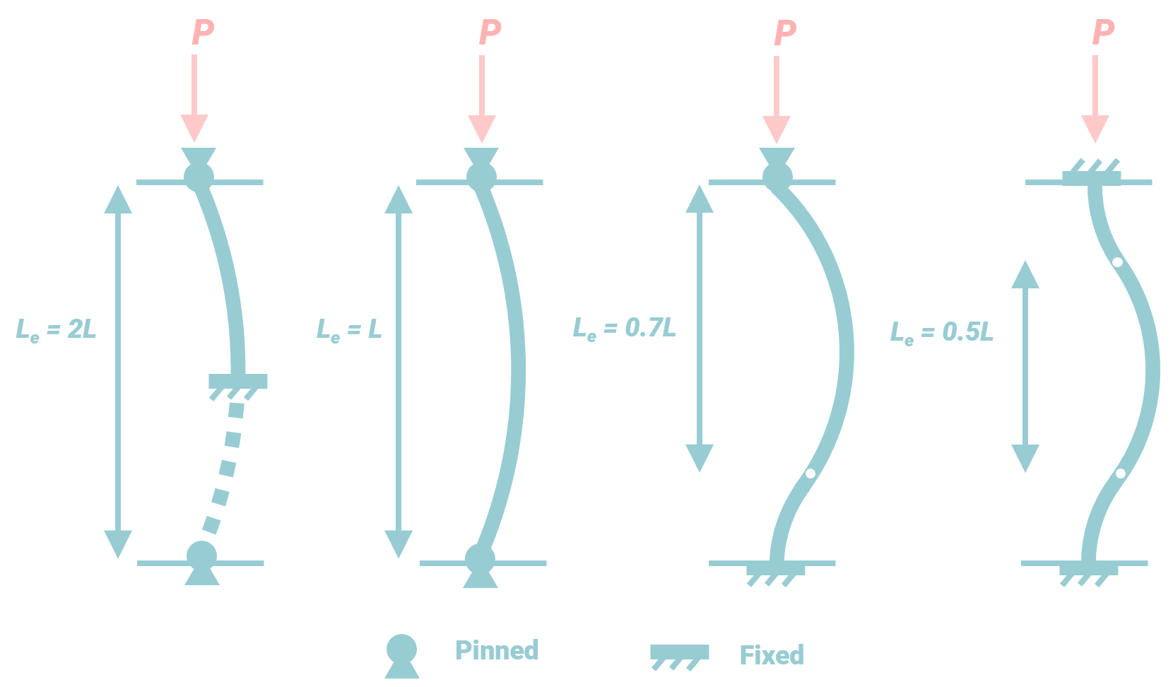

EQUIPMENT AND MATERIAL REQUIRED:

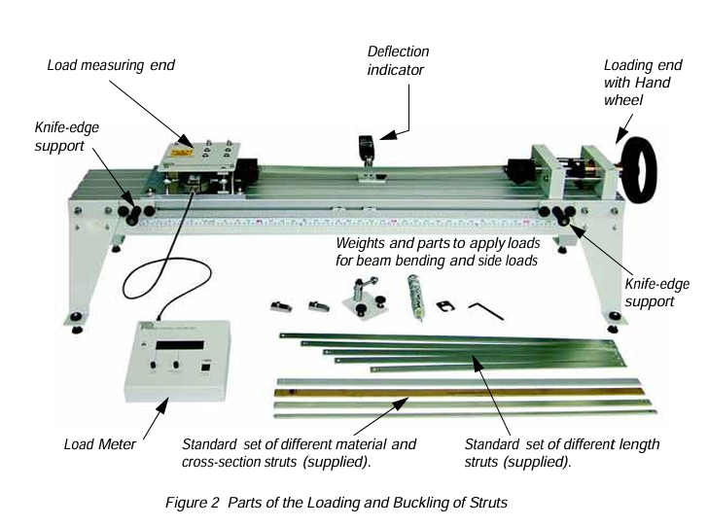

**The Main Part and Load Meter (Display)**

The **Loading and Buckling of Struts** system features an adjustable frame for different strut sizes, with knife-edge supports and a deflection indicator for bending tests. A handwheel applies compression force, while a sensor measures the axial buckling load, displayed on the **Load Meter**. The meter has a **zeroing button** and a **peak hold button** to capture and display the maximum buckling load. This setup is ideal for studying buckling behavior, strut stiffness, and material properties.

**The Struts**

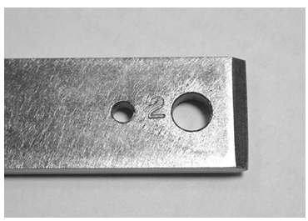 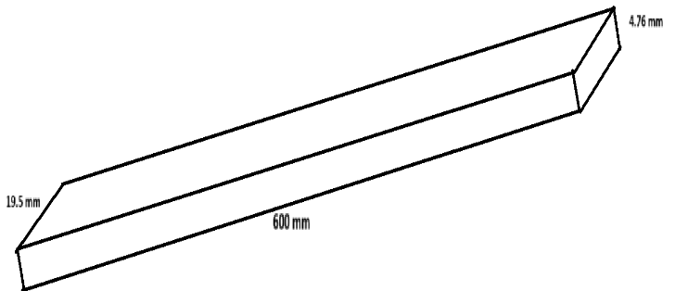

The experiment includes two standard struts, made of steel and brass, both with the same length and thickness. Both have solid metal cross-sections. Optional struts (SM1005A pack) offer different materials and cross-sections, including wood and compound, angle, and channel designs.

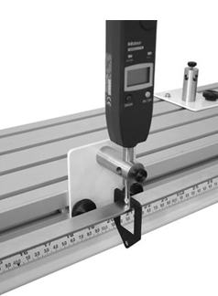**The Deflection Indicator**

The digital deflection indicator measures the deflection of struts and beams.

It mounts on an L-shaped holder for strut tests and a flat holder for beam

bending tests. Connected to TecQuipment’s optional VDAS® for data collection,

it provides accurate, real-time digital readouts. The adjustable weight hanger,

knife edge hanger, and pulley system allow for applying light biasing or side

loads to struts, ideal for side load and deflection tests, as well as beam

bending experiments.

**Eccentric End Fitting**

The experiment includes two special end fittings that apply eccentric (off-center) loads to the struts, with two sides allowing different loading distances. Eccentric loading combines axial compression and bending, leading to increased deformation compared to axial loading alone. The offset distance, or moment arm, influences the bending moment and overall deflection, helping students analyze how load position affects strut stability. This simulates real-world conditions where loads may not align perfectly, providing insights into structural performance and design for off-centered or shifting loads.

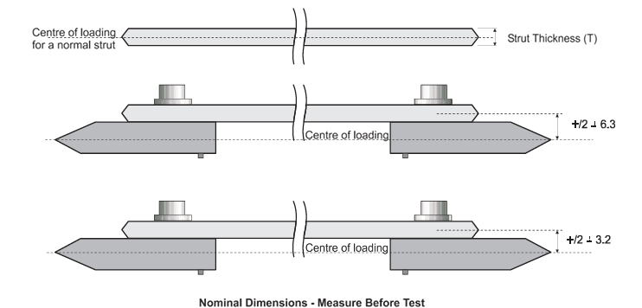

**Weight and Hangers**

The equipment includes a **pulley assembly** for side load tests, used with the **knife edge weight hanger** and cord. The **weight hanger** and **weights** apply vertical loads for beam bending and side load tests, while a second **knife edge weight hanger** ensures precise load application with minimal friction. These components allow students to simulate various loading conditions, aiding in the study of structural behavior.

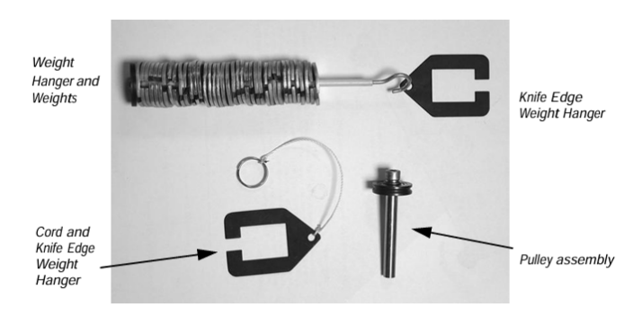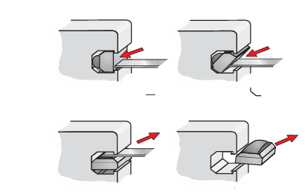

**Adjustable and Removable Fixings**

TecQuipment provides adjustable and movable fixings that can be placed in the slots of the frame to suit a standard arrangement. If needed, you can reposition the **deflection holder** or **beam supports** to the opposite side of the frame. To do so, use a steel rule to carefully remove the fixings and then reinsert them into the desired slots. This flexibility allows for easy adjustment of the setup to accommodate different experimental configurations.

**Versatile Data Acquisition system (VDAS)**

TecQuipment’s **VDAS®** is an optional system for the **Loading and Buckling of Struts** experiment, consisting of hardware and software. It automatically logs, calculates, and generates charts and tables of data, saving time and reducing errors. The system also allows for easy data export to other software for further analysis.

### OBSERVATION TABLE:

1. **DEFLECTION OF SIMPLY SUPPORTED BEAM**
2. **STEEL**

|  |  |  |  |  |  |
| --- | --- | --- | --- | --- | --- |
| **Beam Material: STEEL**  **Distance between supports (L): 600 mm** | | | **Second Moment of Area (I): 171.212 mm4**  **Young’s Modulus (E): 207 GPa** | | |
| **Load (g)** | **Force (N)** | **Measured Deflection (mm)** | **Measured Deflection (m)** | **FL3** | **Theoretical Deflection (y)** |
| **0** | 0 | 0 | 0 | 0 | 0 |
| **100** | 1 | -0.18 | -0.00018 | 0.216 | 0.000127 |
| **200** | 2 | -0.25 | -0.00025 | 0.432 | 0.000254 |
| **300** | 3 | -0.44 | -0.00044 | 0.648 | 0.000381 |
| **400** | 4 | -0.61 | -0.00061 | 0.864 | 0.000508 |
| **500** | 5 | -0.76 | -0.00076 | 1.08 | 0.000635 |

1. **BRASS**

|  |  |  |  |  |  |
| --- | --- | --- | --- | --- | --- |
| **Beam Material: BRASS**  **Distance between supports (L):600 mm** | | | **Second Moment of Area (I): 171.212 mm4**  **Young’s Modulus (E): 105 GPa** | | |
| **Load (g)** | **Force (N)** | **Measured Deflection (mm)** | **Measured Deflection (m)** | **FL3** | **Theoretical Deflection (y)** |
| **0** | 0 | 0 | 0 | 0 | 0 |
| **100** | 1 | -0.12 | -0.00012 | 0.216 | 0.00025 |
| **200** | 2 | -0.33 | -0.00033 | 0.432 | 0.000501 |
| **300** | 3 | -0.59 | -0.00059 | 0.648 | 0.000751 |
| **400** | 4 | -0.79 | -0.00079 | 0.864 | 0.001001 |
| **500** | 5 | -1.03 | -0.00103 | 1.08 | 0.001252 |

1. **STIFFNESS OF STRUT MATERIALS**
2. **STEEL**

|  |  |  |  |  |
| --- | --- | --- | --- | --- |
| **Beam Material: STEEL**  **Beam Width: 19.05 mm**  **Beam Thickness: 4.76 mm**  **Distance between supports (L): 600 mm** | | | **Second Moment of Area (I): 171.212 mm4** | |
| **Load (g)** | **Force (N)** | **Measured Deflection (mm)** | **Measured Deflection (m)** | **FL3/48yI** |
| **0** | 0 | 0 | 0 | 0 |
| **100** | 1 | -0.18 | -0.00018 | -1.5E+11 |
| **200** | 2 | -0.25 | -0.00025 | -2.1E+11 |
| **300** | 3 | -0.44 | -0.00044 | -1.8E+11 |
| **400** | 4 | -0.61 | -0.00061 | -1.7E+11 |
| **500** | 5 | -0.76 | -0.00076 | -1.7E+11 |
| **Calculated Young’s Modulus (E): 146.79 GPa** | | | | |

1. **BRASS**

|  |  |  |  |  |
| --- | --- | --- | --- | --- |
| **Beam Material: BRASS**  **Beam Width: 19.05 mm**  **Beam Thickness: 4.76 mm**  **Distance between supports (L): 600 mm** | | | **Second Moment of Area (I): 171.212 mm4** | |
| **Load (g)** | **Force (N)** | **Measured Deflection (mm)** | **Measured Deflection (m)** | **FL3/48yI** |
| **0** | 0 | 0 | 0 | 0 |
| **100** | 1 | -0.12 | -0.00012 | -2.1903E+11 |
| **200** | 2 | -0.33 | -0.00033 | -1.5929E+11 |
| **300** | 3 | -0.59 | -0.00059 | -1.3364E+11 |
| **400** | 4 | -0.79 | -0.00079 | -1.3308E+11 |
| **500** | 5 | -1.03 | -0.00103 | -1.2759E+11 |
| **Calculated Young’s Modulus (E): 140.59 GPa** | | | | |

1. **DEFLECTED SHAPE OF A STRUT**

Origin is assumed at the centre of the strut at 550 mark on the scale of the apparatus.

1. **STEEL**
2. **PIN – PIN FIXING**

|  |  |  |  |  |
| --- | --- | --- | --- | --- |
| **Beam Material: STEEL**  **Beam Length: 600 mm**  **Beam Dimensions:**  **19.05 mm X 4.76 mm** | | **End Fixing Conditions:**  **PIN – PIN FIXING** | | |
| **Deflection Position**  **(25 mm steps)** | **Deflection Reading (Datum)** | **Deflection Reading (Loaded)** | **Actual Deflection (Loaded - Datum)** |
| **0** | 0 | -5.99 | -5.99 |
| **+50** | -0.23 | -6.58 | -6.35 |
| **+100** | -0.82 | -6.52 | -5.7 |
| **+150** | -0.61 | -6.06 | -5.45 |
| **+200** | -0.47 | -4.54 | -4.07 |
| **+250** | 0.23 | -3.19 | -3.42 |
| **+300** | 0.74 | -1.6 | -2.34 |
| **-50** | 0.27 | -5.5 | -5.77 |
| **-100** | 0.44 | -4.75 | -5.19 |
| **-150** | 0.51 | -3.75 | -4.26 |
| **-200** | 0.34 | -3.10 | -3.44 |
| **-250** | 0.37 | -2.58 | -2.95 |
| **-300** | 0.08 | -1.98 | -2.06 |

1. **PIN – FIXED FIXING**

|  |  |  |  |  |
| --- | --- | --- | --- | --- |
| **Beam Material: STEEL**  **Beam Length: 600 mm**  **Beam Dimensions:**  **19.05 mm X 4.76 mm** | | **End Fixing Conditions:**  **PIN – FIXED FIXING** | | |
| **Deflection Position**  **(25 mm steps)** | **Deflection Reading (Datum)** | **Deflection Reading (Loaded)** | **Actual Deflection (Loaded - Datum)** |
| **0** | 0 | 6.02 | 6.02 |
| **+50** | 0.63 | 6.19 | 5.56 |
| **+100** | 1.32 | 6.2 | 4.88 |
| **+150** | 1.32 | 5.59 | 4.27 |
| **+200** | 1.15 | 4.16 | 3.01 |
| **+250** | 0.81 | 2.49 | 1.68 |
| **+300** | 0.30 | 1.10 | 0.8 |
| **-50** | -0.54 | 5.88 | 6.42 |
| **-100** | -0.84 | 5.17 | 6.01 |
| **-150** | -1.10 | 4.49 | 5.59 |
| **-200** | -1.09 | 3.71 | 4.8 |
| **-250** | -1.00 | 2.22 | 3.22 |
| **-300** | -0.93 | 0.73 | 1.66 |

1. **FIXED – FIXED FIXING**

|  |  |  |  |
| --- | --- | --- | --- |
| **Beam Material: STEEL**  **Beam Length: 600 mm**  **Beam Dimensions:**  **19.05 mm X 4.76 mm** | | **End Fixing Conditions:**  **FIXED – FIXED FIXING** | |
| **Deflection Position**  **(25 mm steps)** | **Deflection Reading (Datum)** | **Deflection Reading (Loaded)** | **Actual Deflection (Loaded - Datum)** |
| **0** | 0 | -6.00 | -6 |
| **+50** | 0.79 | -3.7 | -4.49 |
| **+100** | 1.77 | -1.77 | -3.54 |
| **+150** | 1.77 | -0.24 | -2.01 |
| **+200** | 1.70 | 0.73 | -0.97 |
| **+250** | 1.48 | 1.22 | -0.26 |
| **+300** | 1.19 | 1.31 | 0.12 |
| **-50** | -0.66 | -7.16 | -6.5 |
| **-100** | -1.32 | -7.88 | -6.56 |
| **-150** | -1.33 | -7.96 | -6.63 |
| **-200** | -1.79 | -6.24 | -4.45 |
| **-250** | -1.36 | -4.49 | -3.13 |
| **-300** | -0.79 | -2.16 | -1.37 |

1. **BRASS**
2. **PIN – PIN FIXING**

|  |  |  |  |  |
| --- | --- | --- | --- | --- |
| **Beam Material: BRASS**  **Beam Length: 600 mm**  **Beam Dimensions:**  **19.05 mm X 4.76 mm** | | **End Fixing Conditions:**  **PIN – PIN FIXING** | | |
| **Deflection Position**  **(25 mm steps)** | **Deflection Reading (Datum)** | **Deflection Reading (Loaded)** | **Actual Deflection (Loaded - Datum)** |
| **0** | 0 | 6.00 | 6 |
| **+50** | -0.1 | 5.65 | 5.75 |
| **+100** | -0.14 | 5.33 | 5.47 |
| **+150** | -0.15 | 4.84 | 4.99 |
| **+200** | -0.36 | 3.76 | 4.12 |
| **+250** | -0.49 | 2.61 | 3.1 |
| **+300** | -0.94 | 1.21 | 2.15 |
| **-50** | -0.27 | 5.36 | 5.63 |
| **-100** | -0.4 | 4.7 | 5.1 |
| **-150** | -0.69 | 3.65 | 4.34 |
| **-200** | -1.11 | 2.36 | 3.47 |
| **-250** | -1.67 | 0.89 | 2.56 |
| **-300** | -2.2 | -0.38 | 1.82 |

1. **PIN – FIXED FIXING**

|  |  |  |  |  |
| --- | --- | --- | --- | --- |
| **Beam Material: BRASS**  **Beam Length: 600 mm**  **Beam Dimensions:**  **19.05 mm X 4.76 mm** | | **End Fixing Conditions:**  **PIN – FIXED FIXING** | | |
| **Deflection Position**  **(25 mm steps)** | **Deflection Reading (Datum)** | **Deflection Reading (Loaded)** | **Actual Deflection (Loaded - Datum)** |
| **0** | 0 | 6.00 | 6 |
| **+50** | -0.35 | 5.88 | 6.23 |
| **+100** | 0.09 | 5.59 | 5.5 |
| **+150** | 0.59 | 5.08 | 4.49 |
| **+200** | 0.63 | 4.22 | 3.59 |
| **+250** | 0.53 | 3.15 | 2.62 |
| **+300** | 0.39 | 2.00 | 1.61 |
| **-50** | -0.04 | 5.73 | 5.77 |
| **-100** | -0.10 | 5.61 | 5.71 |
| **-150** | -0.25 | 5.17 | 5.42 |
| **-200** | -0.50 | 4.20 | 4.7 |
| **-250** | -0.84 | 2.77 | 3.61 |
| **-300** | -1.21 | 0.92 | 2.13 |

1. **FIXED – FIXED FIXING**

|  |  |  |  |
| --- | --- | --- | --- |
| **Beam Material: BRASS**  **Beam Length: 600 mm**  **Beam Dimensions:**  **19.05 mm X 4.76 mm** | | **End Fixing Conditions:**  **FIXED – FIXED FIXING** | |
| **Deflection Position**  **(25 mm steps)** | **Deflection Reading (Datum)** | **Deflection Reading (Loaded)** | **Actual Deflection (Loaded - Datum)** |
| **0** | 0 | 6.05 | 6.05 |
| **+50** | 0.45 | 6.12 | 5.67 |
| **+100** | 0.72 | 5.94 | 5.22 |
| **+150** | 0.91 | 5.18 | 4.27 |
| **+200** | 0.97 | 3.77 | 2.8 |
| **+250** | 0.77 | 2.18 | 1.41 |
| **+300** | 0.36 | 0.78 | 0.42 |
| **-50** | -0.08 | 5.85 | 5.93 |
| **-100** | -0.03 | 5.43 | 5.46 |
| **-150** | -0.08 | 4.39 | 4.47 |
| **-200** | -0.23 | 2.93 | 3.16 |
| **-250** | -0.57 | 1.34 | 1.91 |
| **-300** | -0.89 | -0.24 | 0.65 |

1. **COMPARING BUCKLING LOADS WITH END CONDITIONS**

|  |  |  |  |  |
| --- | --- | --- | --- | --- |
| **Second Moment of Area for the Strut:** | | | | |
| **Fixing Condition** | **Strut** | **Peak (Buckling) Load 1** | **Peak (Buckling) Load 2** | **Average Peak (Buckling) Load** |
| **Pinned - Pinned** | STEEL | 514 | 531 | 522.5 |
| **Pinned - Fixed** | STEEL | 1125 | 1069 | 1097 |
| **Fixed - Fixed** | STEEL | 1426 | 2161 | 1793.5 |
| **Pinned - Pinned** | BRASS | 286 | 350 | 318 |
| **Pinned - Fixed** | BRASS | 645 | 671 | 658 |
| **Fixed - Fixed** | BRASS | 1368 | 1309 | 1338.5 |

### CALCULATIONS:

The error in the calculation of Young’s modulus is identified and can be quantified as:

Error = x 100

Error in young’s modulus of steel = x 100

= 29.08%

Error in young’s modulus of brass = x 100

= 33.89%

### GRAPHS:

1. **DEFLECTION OF SIMPLY SUPPORTED BEAM**
2. **STEEL**
3. **BRASS**

1. **DEFLECTED SHAPE OF A STRUT**
2. **STEEL**
3. **BRASS**

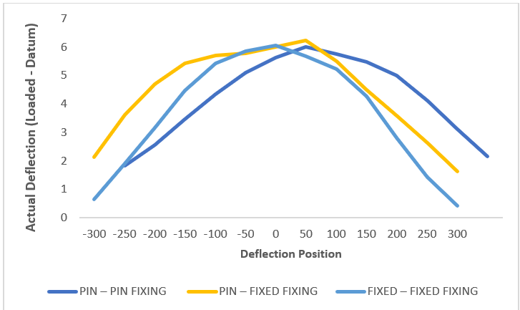

### ANALYSIS:

1. **DEFLECTION OF SIMPLY SUPPORTED BEAM**
2. **STEEL**

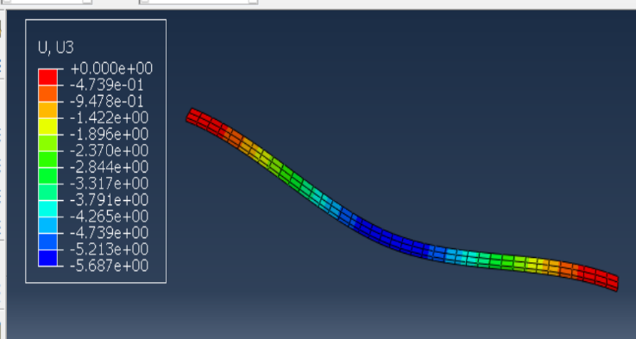

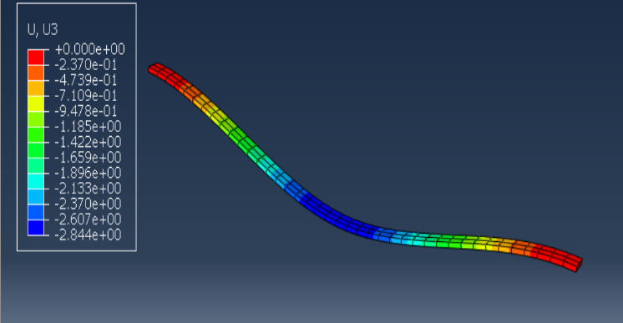

**Weight = 100g Weight = 200g**

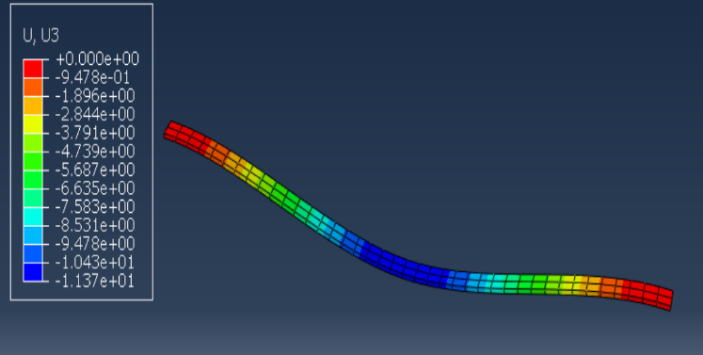

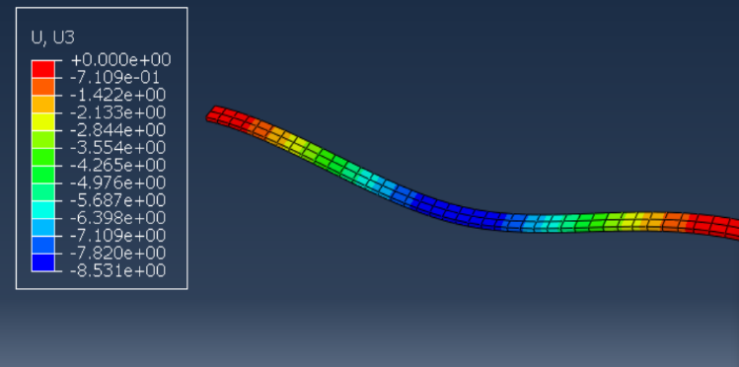

**Weight = 300g Weight = 400g**

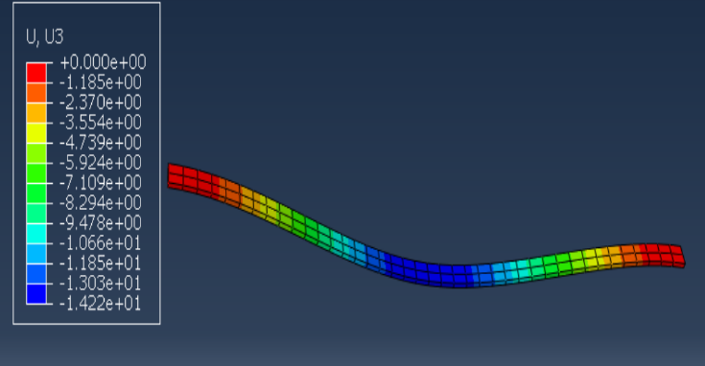

**Weight = 500g**

1. **BRASS**

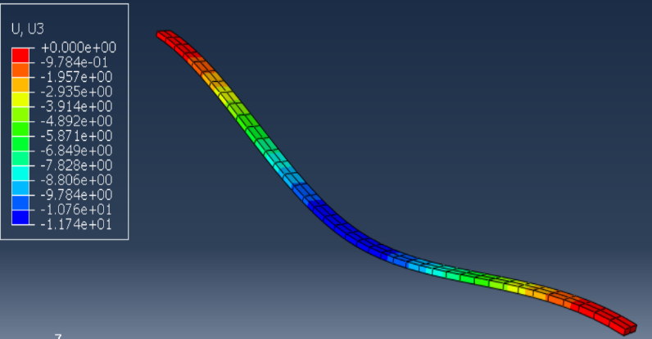

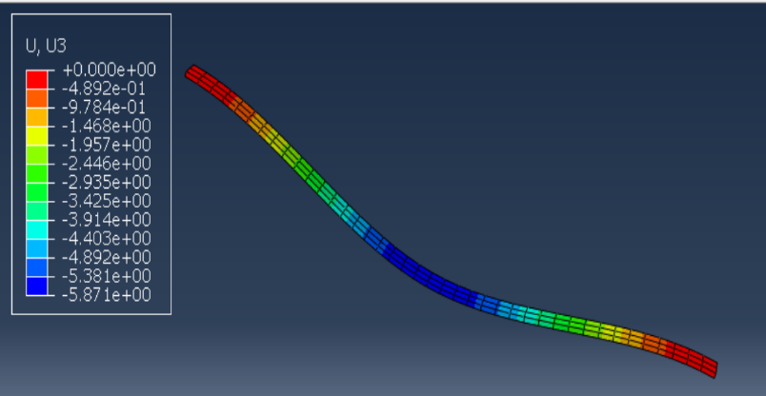

**Weight = 100g Weight = 200g**

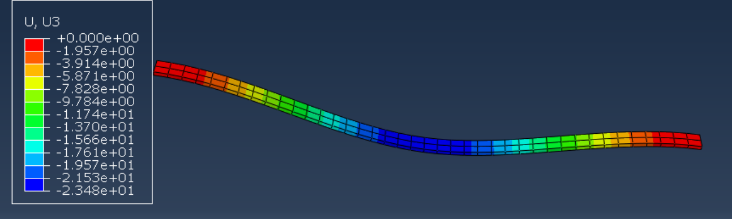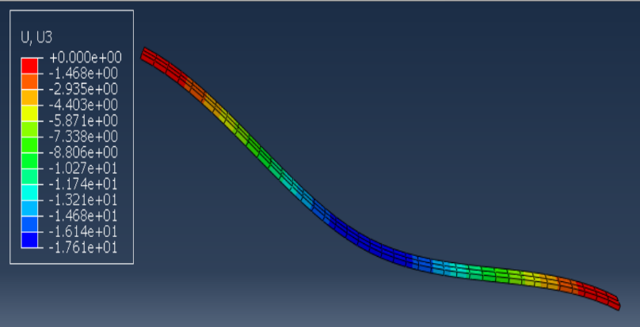

**Weight = 300g Weight = 400g**

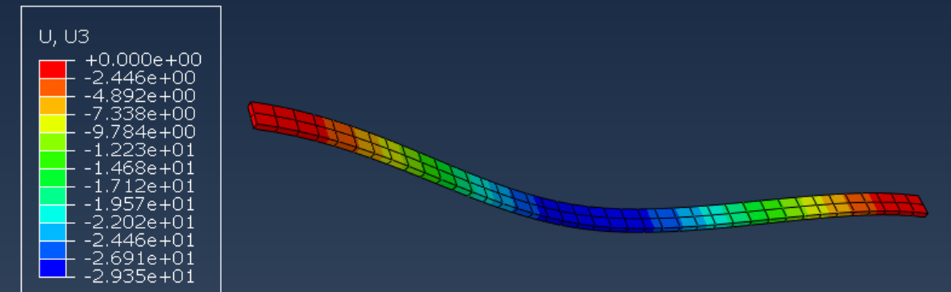

**Weight = 500g**

1. **DEFLECTED SHAPE OF A STRUT**
2. 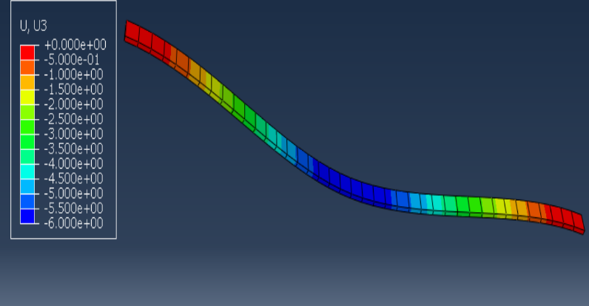**STEEL**

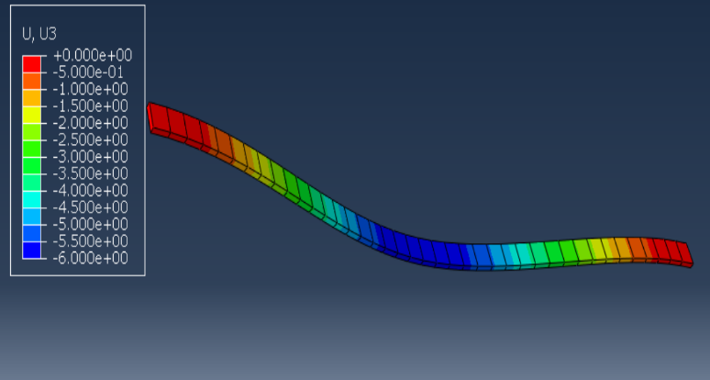

**FIXED – FIXED FIXING PIN – FIXED FIXING**

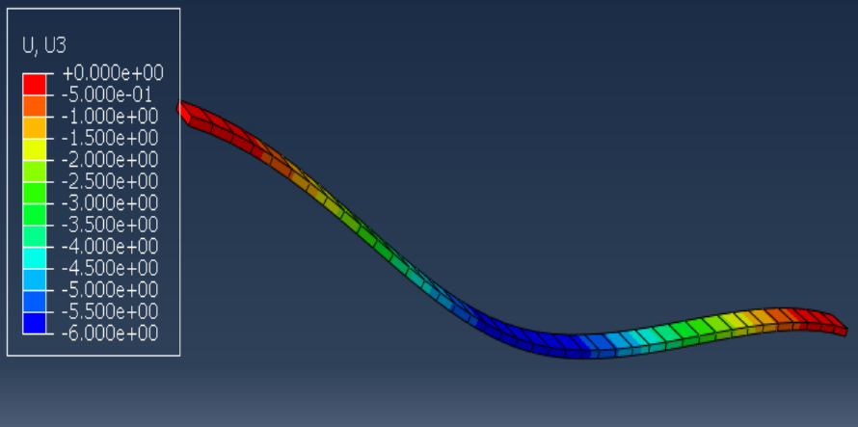

**PIN – PIN FIXING**

1. 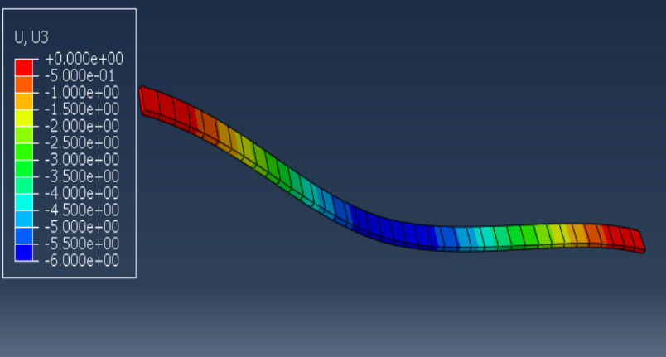**BRASS**

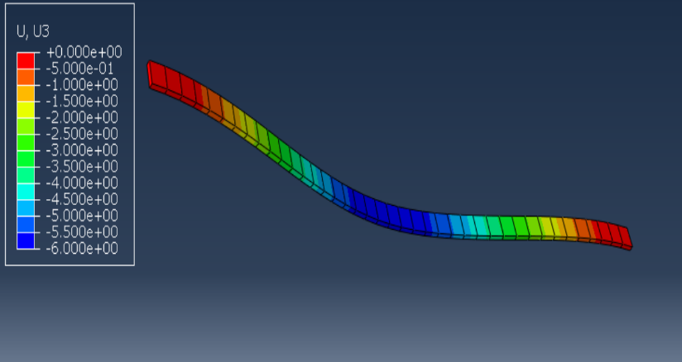

**FIXED – FIXED FIXING PIN – FIXED FIXING**

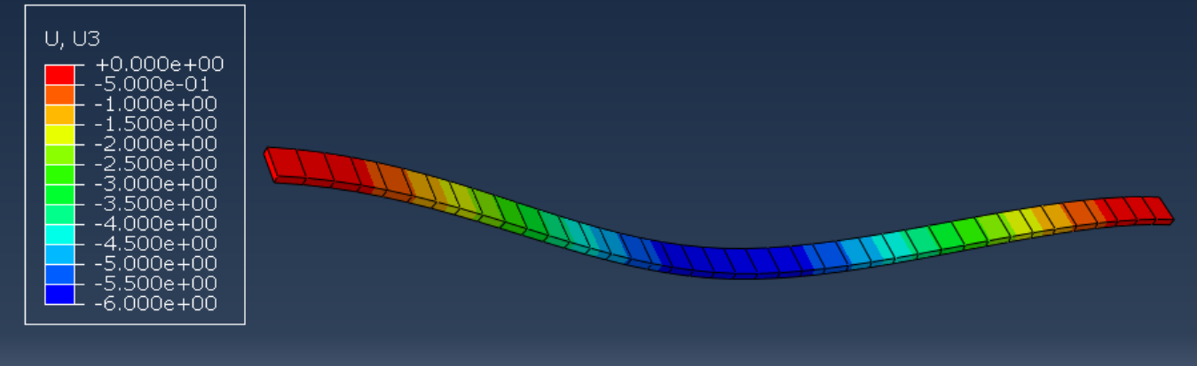

**PIN – PIN FIXING**

### COMPARISION WITH THEORY:

In this experiment, we first investigated the bending of a strut by applying load masses and observing the resulting deflection due to bending. The phenomenon of bending can be explained by theory, where the weight applied at the center of the strut causes it to bend in a specific manner, as observed during the experiment. After measuring the deflection, we calculated the Young’s Modulus of the strut, which confirmed that the bending behavior is dependent on the material's stiffness, as described by Young’s Modulus.

Next, we explored the buckling of the strut, where we realized that the orientation of the applied force significantly affects how the strut deforms, either bending or buckling. Through theoretical analysis, we examined how the **moment of area** plays a crucial role in determining the extent of deformation. Finally, we performed an experiment to verify the **critical load** for first-order buckling and compared the results with theoretical predictions, observing the formation of a wave pattern during buckling.

Overall, these four experiments provided valuable insights into the bending and buckling behaviors of beams, helping us understand the influence of material properties, force orientation, and geometry on structural performance.

### CONCLUSION AND DISSCUSSION:

The **Loading and Buckling of Struts** experiment offers valuable insights into the behavior of structural elements, like columns and struts, under compressive forces. It helps us understand material response to compression, the concept of critical load (the point of failure due to instability), and the impact of boundary conditions and geometric properties on buckling behavior. The experiment also validates key theoretical concepts, such as **Young's Modulus** and **critical load**, bridging the gap between theory and practice in structural design.

In the **bending of beams**, the theoretical predictions for deflection typically provide a good approximation in the elastic range, though real-world factors—like material imperfections, eccentric loading, and inaccuracies in supports—can lead to discrepancies in observed deflections. Material non-linearity, improper load application, and environmental factors further contribute to these errors.

The wave pattern observed during strut buckling is crucial for understanding **critical load** and structural stability. It reflects how boundary conditions and geometric properties influence the buckling behavior. The first buckling mode shows a single wave, while higher modes display more complex wave patterns. Understanding these patterns helps predict failure points and optimize structural designs.

In the **critical buckling experiment**, lower-than-expected results for the fixed-fixed condition may occur due to the load on the fixings. As the strut buckles, the lateral displacement induces additional forces on the fixings, leading to imperfections in the boundary conditions. This reduces the restraint provided by the fixings, lowering the stability and causing premature buckling. Deformations at the fixings can further reduce the effective length of the strut, decreasing the critical buckling load.

Lastly, obtaining **second-order buckling** requires fixing the center of the strut, as the strut must pass through the second mode directly. In general, most analysis focuses on the **first mode**, where buckling is more readily observed.

In conclusion, these experiments provide a deeper understanding of bending, buckling, and structural stability. By addressing the practical challenges and inherent errors in experimental setups, engineers can design more reliable and stable structures.

ADDITIIONAL DISSCUSSION:

**Boundary Condition**

Boundary conditions define the constraints applied to a structure or system during analysis, specifying how the ends of beams or struts are supported or fixed. Common types include Fixed (Clamped), where both translation and rotation are restricted; Simply Supported, which restricts translation but allows rotation; Pinned, which restricts translation but permits rotation; and Free, with no restrictions on translation or rotation. These conditions significantly affect the structure's deformation, stress distribution, and stability under applied loads.

**Degree of freedom**

Degree of freedom (DOF) refers to the number of independent motions a system or structure can undergo. In structural analysis, it represents the number of independent displacements (translations and rotations) that can occur at each point. For example, in a 2D system, a point can have two translational DOFs (moving in the X and Y directions) and one rotational DOF (rotation about a perpendicular axis). The DOF helps in determining the number of equations needed to solve for the system's response.

**Young’s Modulus**

Young's Modulus, also known as the elastic modulus, is a material property that measures a material's stiffness or resistance to deformation under stress. It is defined as the ratio of stress (force per unit area) to strain (relative deformation) in the elastic region of the material's stress-strain curve. A higher Young's Modulus indicates a stiffer material that deforms less under applied load. It is typically expressed in Pascals (Pa) and is used in engineering to predict how materials will respond to tensile or compressive forces.

**Poisen’s Ratio**

Poisson's Ratio is a material property that describes the relationship between lateral strain and axial strain when a material is stretched or compressed. It is defined as the ratio of the strain in the lateral direction (perpendicular to the applied force) to the strain in the axial direction (parallel to the applied force). For most materials, Poisson's Ratio is positive, meaning that when a material is stretched, it contracts in the perpendicular direction, and vice versa. Typical values range from 0 to 0.5, with 0.5 indicating a perfectly incompressible material. It is used in engineering to predict material behavior under stress.

**Moment of Area**

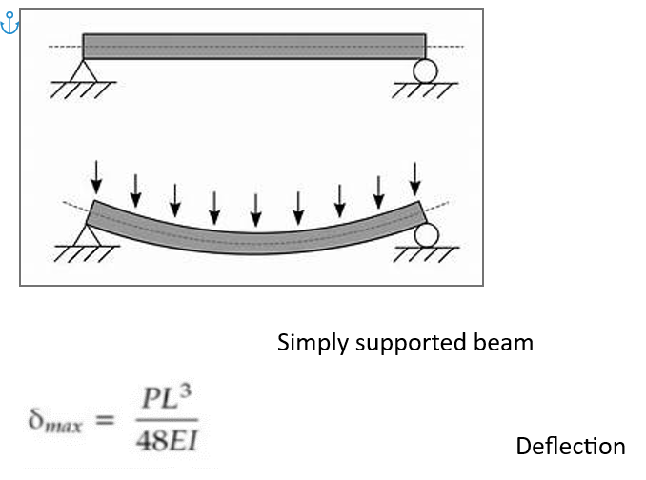The Moment of Area, also known as the second moment of area or area moment of inertia, is a geometric property of a shape that reflects its resistance to bending or flexural deformation. It is calculated by integrating the square of the distance from a given axis to the differential area element. The larger the moment of area, the more resistant the shape is to bending.

For example, for a rectangular section, the moment of

area about its horizontal centroidal axis is given by:

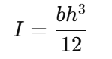

where b is the width and h is the height. The moment of

area is crucial in beam bending analysis and helps

engineers design structures that can withstand applied

loads with minimal deflection.

**Simply Supported beam**

A beam supported in the simplest way possible.

### REFRENCE:

* [**https://web.iitd.ac.in/~ajeetk/smb/BendingofBeams.html**](https://web.iitd.ac.in/~ajeetk/smb/BendingofBeams.html)
* [**https://www.bu.edu/moss/mechanics-of-materials-beam-buckling/**](https://www.bu.edu/moss/mechanics-of-materials-beam-buckling/)
* [**https://web.mit.edu/16.20/homepage/9_Buckling/Buckling_files/module_9_with_solutions.pdf**](https://web.mit.edu/16.20/homepage/9_Buckling/Buckling_files/module_9_with_solutions.pdf)
* [**https://thisvsthat.io/bending-vs-buckling**](https://thisvsthat.io/bending-vs-buckling)